JWood Raw Elementary School
Progressive Discipline Plan

At JWood Raw our goal is to create a positive school environment that encourages the development of the maximum potential of each student.

The staff at JWood Raw Elementary handle behavior through positive reinforcement, high engagement, and empowering students to solve problems through teacher facilitation. Students are taught the following PRIDE expectations: Perseverance, Respect, Integrity, Determination, and Empathy.
JWood Raw Elementary implements the following curriculum which focuses on appropriate social and academic behaviors and promotes a positive learning environment.
Our Progressive Discipline Plan adheres to the guidelines set forth by NRS 392.4644, 392.463, and supports teachers and students in maintaining a school climate of high academic standards, and a safe and positive school culture.
Preventative Actions and Curriculum Implementation to Ensure a Positive and School Environment:
- Clearly communicate expectations.
- Integrate Social Emotional Learning Standards
- Quaver Lessons
- Harmony Lessons/Cards
- Restorative Practices
- Class Meetings
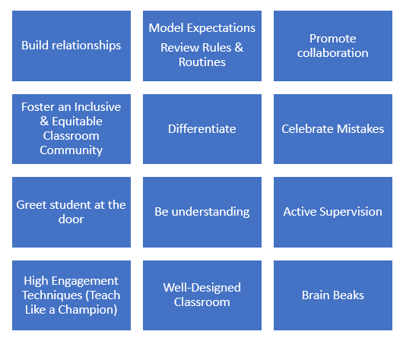
- Family Communication: positive messages & phone calls home, newsletters, connect ed calls, website, school wide events.
- Guidance Lessons (Counselor)

School-Wide Expectations:
During the first two weeks of school, teachers teach students school-wide behaviors expectations for the playground, cafeteria, restrooms, hallways, arrival, and dismissal. The administrators will schedule a Behavior Assembly for K-5 during the first week of school. The following school wide expectations are the basis of instruction for all students.
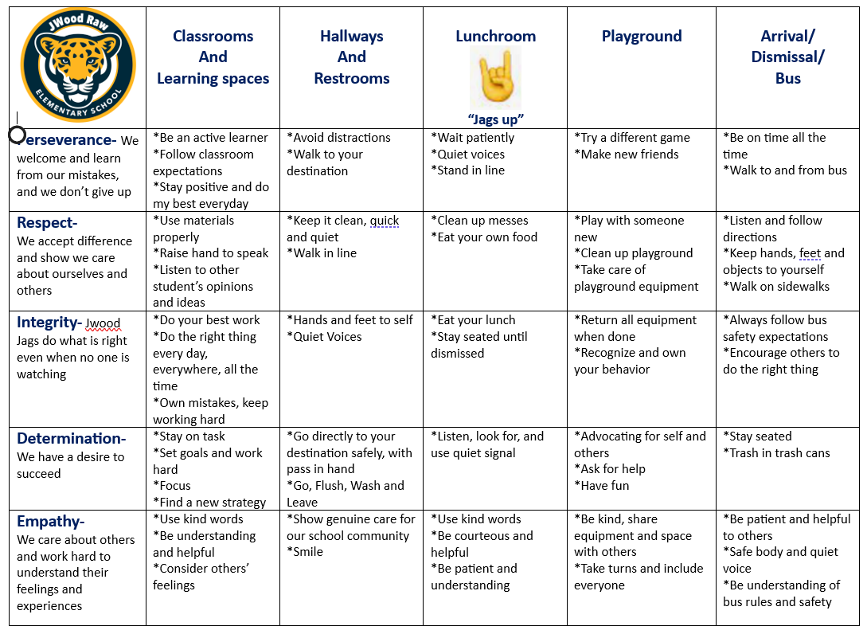

School Discipline Plan and Consequences:
When positive reinforcement and classroom interventions are not working, students are assigned consequences. Age, developmental/cognitive level of students, and maturity are taken into consideration when determining appropriate consequences for students.
Behavior Modification Flowchart: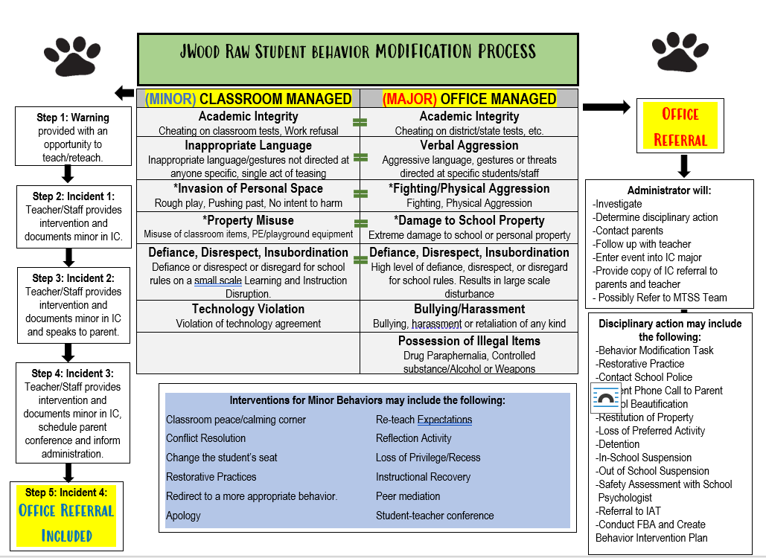

Plan for Minor and Major Behaviors and Removal from Classroom

- Teachers will implement a behavior management plan in their classroom and will notify students, parents, and administration of their plan.

- Teachers are expected to handle their discipline by using effective procedures: respect and caring for students, re-teaching of expectations, honoring confidentiality, student self-reflection, and patience. (i.e., better decisions based on safe, responsible, respectful, and kind behavior). Parent notification by teacher needs to take place if a student has a loss of a privilege.

- If above is not working or a student continues to misbehave, the following will be implemented:

- Temporary alternate placement – other teacher classroom, outside the classroom door, or a specific place within the class. Changing the placement of a misbehaving student is a proven, effective practice and will be used before sending a student to the office. The teacher will notify parent if this discipline practice is used.

- A citation may be issued for a minor behavior incident. The teacher will assign a consequence for minor behaviors which may include, but are not limited to, a reflection activity, apology, loss of recess or privilege. The teacher will notify parents within 24 hours.

- If like behaviors are continued, minor behaviors become a major. If a behavior event is considered a major, the teacher may send the student to the office. At this time, administration may use reflection activity, loss of privilege, behavior contract, school beautification, or suspension (in house or out of school suspension). The teacher and/or administrator will contact parents to notify them of their child’s behavior within 24 hours.

- A student will be removed from the classroom if an office referral is warranted, administrative intervention is needed, is disruptive to the learning of self and others, or is a safety concern to others. (NRS 392.4645)
- If a student is removed from the classroom (i.e., suspension), per NRS 392.4645, the principal/assistant principal of the school shall provide an explanation of the reason for the removal of the student and offer the student an opportunity to respond to the explanation. The administrator will notify parents or legal guardian within 24 hours if a student is removed from the classroom.

- If the student continues to misbehave, a conference will take place involving an administrator, teacher, parents, and student. A referral to our MTSS team may be necessary to determine interventions and possible change of placement if warranted.

Please note: If at any time a student is a safety concern for him/herself, other students, and teachers, all these steps should be skipped, and the student should be sent directly to the office.

Minor and Major Behavior Documentation
Minor Behaviors
- Teachers will manage minor behaviors in IC using the Behavior Minor tab if applicable.
- The behavior tracking form (i.e., citation) and/or print out of minor behavior can be generated from the ABC Reports in IC to be sent home to parents; teachers will notify parents of the behavior incident.

Major Behaviors
- Administrator will document major behavior occurrences in IC
- Administrator will notify parents of behavior and consequence.

